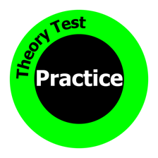
Attitude Worksheet

No. | Question | Answer
1 | What gap should you leave between you and the car in front when dry?  What gap should you leave between you and the car in front when the road is wet?  How many times the gap should you leave in icy weather?
2 | When can you use your horn?
3 | What is the main cause of accidents?
4 | Who can use Toucan crossings?
5 | The green car is waiting in the yellow box junction. Is that ok? Why? | See Image 1
6 | What is a Puffin Crossing?
7 | What is a Pelican Crossing?
8 | At a level crossing, you will see amber lights first. What other warning is there?
9 | What is the traffic light sequence?  (Colour it in to help you remember) | See Image 2
10 | What type of crossing is this? | See Image 3

EXTRA QUESTIONS
Blue flashing lights are used on…
Green flashing lights are used on…
Amber flashing lights are used on…
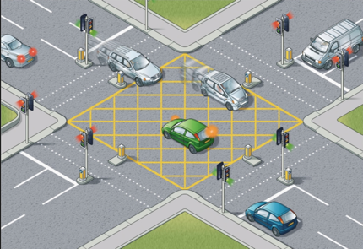
Image 1

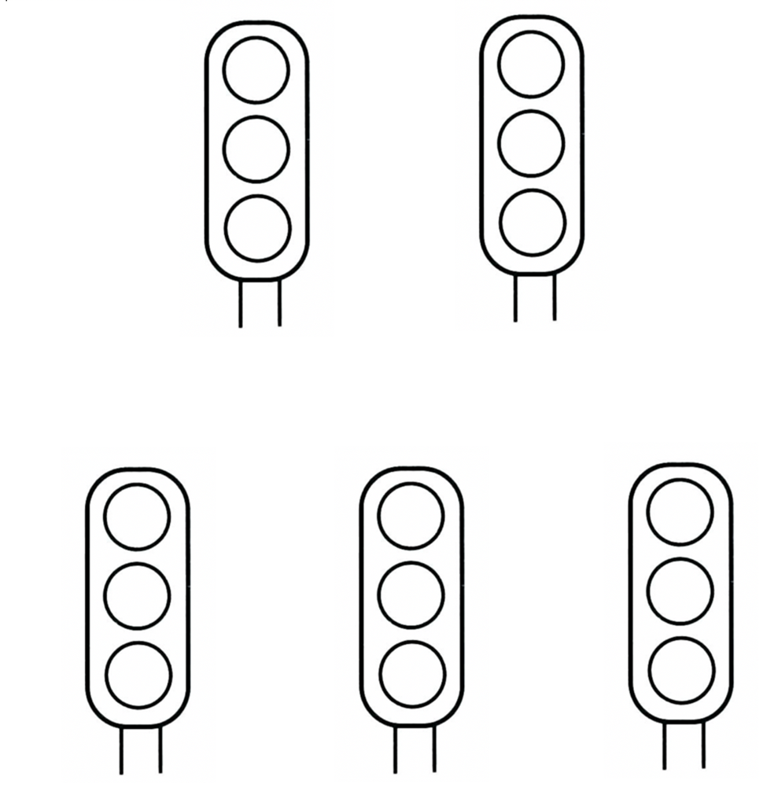
Image 2

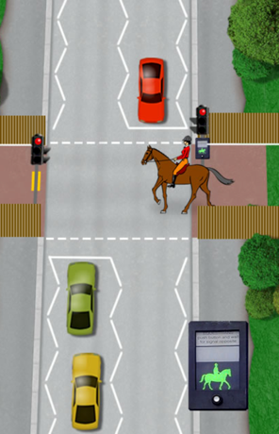
Image 3

