Documents Worksheet
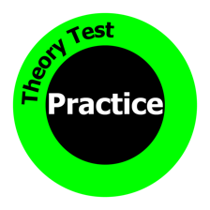

No. | Question | Answer
1 | Who’s responsible for keeping the ‘vehicle registration certificate’ updated?
2 | What’s the legal minimum insurance?
3 | What does ‘Third-party, fire and theft’ cover you for?
4 | What’s the best type of insurance?
5 | What’s a Cover Note?
6 | What’s the maximum fine for driving without insurance?
7 | When do you need your first MOT?  How long is a MOT valid for?
8 | What do you need before you can tax a car?
9 | What does S O R N mean?  How long is SORN valid?
10 | How long do you have before you need to produce your documents to the police?

