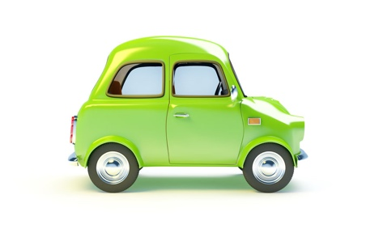
Other Types of Vehicles Worksheet

No. | Question | Answer
1 | Why might the rear wheels of a car hit the kerb?
2 | A lorry in front of you is turning left. Where would you expect the driver to steer first?
3 | A lorry ahead of you is signalling right at a roundabout. Why might the driver stay in the left-hand lane?
4 | What is the first thing you need to check as you approach a bus stop?
5 | What might pedestrians do at a bus stop?
6 | You are approaching a bus stop. What must you do if the bus signals to pull out in front of you?
7 | Which 3 vehicles are most likely to be affected by side wind? | Cyclists Motorcyclists  High sided vehicles Cars
8 | Which vehicle is least likely to be affected by side wind? | Cyclists Motorcyclists  High sided vehicles Cars
9 | You are driving in the rain. Other vehicles are causing spray. Which lights must you put on?
10 | When towing a caravan, what type of mirrors can you attach to your side mirrors?

