Road and Traffic Signs Facts List
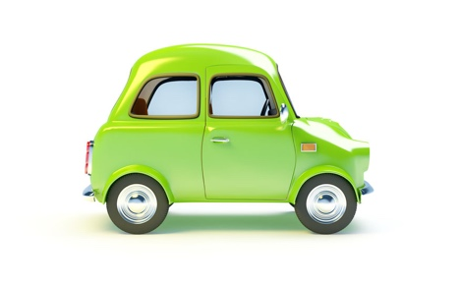

Shapes of Signs

1 | Circle signs give orders
2 | Red circles tell you what you must not do
3 | Blue circles give a mandatory instruction, this means they tell you what you must do
4 | Rectangle signs are for information
5 | Brown rectangles are tourist signs
6 | White rectangles are for directions to non-primary routes
7 | Green rectangles are for directions on primary routes
8 | Blue rectangles are for information and are used on motorways
9 | Triangle signs are warning signs
Road Markings

10 | You’d see a contraflow bus and cycle lane on a one-way street
11 | Zig zag lines at pedestrian crossings mean no parking at anytime
Lines on the Road

12 | You must not cross or straddle a solid white line in the centre of the road unless:  - You are turning into a junction  - You need to pass a stationary vehicle  - You need to overtake a cyclist, horse or road maintenance vehicle if they are moving at 10 mph or less
Traffic lights

13 | Red light means you must stop and wait behind the stop line
14 | Amber light means stop at the stop line
15 | Green light means go if it is safe
16 | Flashing amber means go if the crossing is clear
Using the Horn and Hazard Lights

17 | You should not use your horn between 11.30pm and 7.00am
18 | You may use your hazard warning lights on a motorway or unrestricted dual carriageway, to warn of a hazard ahead
Other

19 | A police officer in a patrol vehicle will signal you to stop by flashing their headlights, indicating left and pointing to the left

