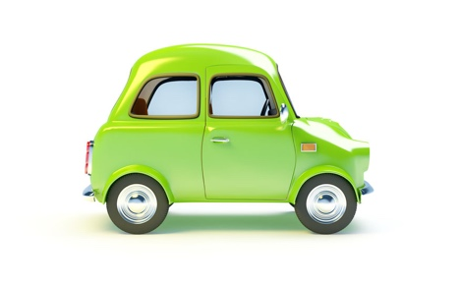
Road and Traffic Signs Worksheet

No. | Question | Answer
1 | What shape signs give orders?
2 | Blue circles give a mandatory instruction. What does this mean?
3 | What shape are warning signs?
4 | Rectangle shape signs are information signs. What colour rectangle signs are used on motorways?
5 | What do zig zag lines on a road mean?
6 | You are approaching traffic lights. They are on amber. What colour will appear next?
7 | What times are you not allowed to use your horn?
8 | When may you use your hazard warning lights?
9 | How will a police officer in a patrol car signal you to stop?
10 | There is a solid white line in the centre of the road. When are you allowed to cross or straddle it?

