Rules of the Road Facts List
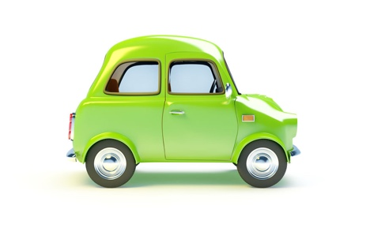

Speed Limits

1 | The national speed limit for cars and motorcycles on single carriageway roads is 60 mph
2 | The national speed limit for cars and motorcycles on motorways and dual carriageways is 70 mph
3 | The speed limit for cars towing on single carriageway roads is 50 mph
4 | The speed limit for cars towing on motorways and dual carriageways is 60 mph
5 | On a road with streetlights, but no speed limit signs, the speed limit is usually 30 mph
Box Junctions and Crossroads

6 | At an unmarked crossroads no one has priority
7 | You may stop and wait in a box junction when oncoming traffic prevents you from turning right
Parking

8 | The nearest you can park to a junction is 10 metres (32 feet)
9 | You must not park on a pedestrian crossing or on zig zag lines
10 | Never park in a disabled only parking space unless permitted i.e. you are a blue badge holder.
Reversing

11 | You must not reverse for longer than necessary
12 | Never reverse from a side road onto a main road
13 | When reversing, you are more of a hazard to other road users when you steer, and the front of your car swings out
Pedestrian Crossings

14 | At a Zebra Crossing, pedestrians have priority. You must not wave them across the road, let them make their own decision
15 | Toucan Crossings can be use by cyclists and pedestrians
16 | Pelican Crossings have a flashing amber light. This means you must give way to pedestrians who are still crossing, but you can continue if the crossing is clear
17 | Puffin Crossings have a sensor
18 | Pegasus Crossings are for pedestrians and horse riders
Bus and Cycle Lanes

19 | You must not drive in a bus lane during its hours of operation. The hours of operation will be marked on the bus lane road sign.
20 | You must not drive in a cycle lane marked by a solid white line during its period of operation.
21 | A cycle lane marked by a broken white line means you should not drive in, or park in the lane unless it is unavoidable.
Other

22 | When waiting at a level crossing if the red lights continue to flash after a train has passed, you must continue to wait
23 | If a car overtakes you at night and you have your headlights on full beam, you should switch them to dipped as soon as the vehicle passes you

