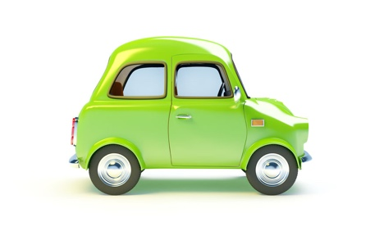
Rules of the Road Worksheet

No. | Question | Answer
1 | You are driving through a town with regular street lighting but no speed limit sign. What is the speed limit on this road?
2 | What is the speed limit for a car towing a caravan on a dual carriageway?
3 | Who can use Toucan crossings?
4 | You are at a pedestrian crossing and there is a flashing amber light. What can you do?
5 | When may you drive without wearing a seatbelt?
6 | You are about to reverse around a corner. When is your car causing the greatest hazard to other road users?
7 | At an unmarked crossroads, who has priority to go first?
8 | What are the rules for parking at night on a road?
9 | You are driving along and there are cars parked on your side of the road. There is a van driving towards you. Who has priority?
10 | At a crossroads you want to turn right. The car approaching you is also turning right. If you both turn together it is best to turn offside to offside or nearside to nearside?  Remember:  Offside is Driver’s side.  Nearside is the side of the car Near the Kerb

