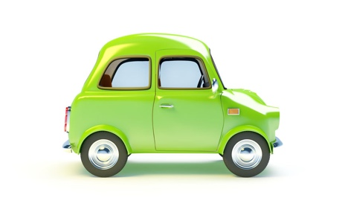
Vulnerable Road Users Worksheet

No. | Question | Answer
1 | Who are the most vulnerable road users?
2 | Dogs trained to help deaf people have a coat. What colour is the coat?
3 | Why would a pedestrian carry a white stick with a red band?
4 | What should you do if you see flashing amber lights under a school warning sign?
5 | You are driving behind a cyclist who is approaching a roundabout. The cyclist is in the left-hand lane. What direction would you expect the cyclist to go?
6 | Why do motorcyclists wear bright clothing?
7 | You are approaching traffic lights. You notice advance stop lines. What are they for?
8 | You are driving on a rural road. What would you expect to see on your side of the road?
9 | What other things would you expect to see on rural roads?  (Name 5 things)
10 | If a disability scooter use was travelling on a dual carriageway, they would have flashing lights to warn that they are slow-moving. What colour would the lights be?

