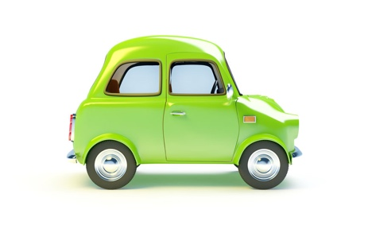
Vehicle Loading Worksheet

It’s the Summer Holidays! The Edwards family of are going away to North Wales on a caravan holiday.

There’s Mum and Dad, Jack is almost 3, Rose is 6 and William is 7.

They are taking Fred, their family dog.

Yesterday, Dad had taken William and Rose out with him to put more air in the tyres.

Q: 1 – Why had Dad put more air in the tyres?

____________________________________________________________________

They’re leaving soon. Mum and Dad are busy putting the caravan onto the tow bar while the 3 children excitedly pack some toys and books.

Mum asks, “What’s the maximum noseweight of our tow ball?”
“I can’t remember, check in the handbook, said Dad”

Q: 2 – What is the noseweight?

____________________________________________________________________

They put bikes on the back of the caravan. Dad made sure the bikes were really securely fastened. He knows that, as the driver, it’s his responsibility.

They’re almost ready to leave. Mum fetches the children while Dad attaches the breakaway cable.

Q: 3 – What is a Breakaway cable?

____________________________________________________________________

They’re finally on the road. “There’s not enough space in the back”, grumbles William, “There’s too many bags. Why can’t I travel in the caravan?”

Q: 4 – Is it ok for William to travel in the caravan?

____________________________________________________________________

“Shall I put Fred in the front with me?” said Mum

Dad didn’t agree. He knows the dog will want to sit on his lap. “He needs to be properly restrained so he doesn’t interfere with my driving,” he responded.

“Are we nearly there yet? Are we nearly there yet?” chant all three of them, after only 10 minutes into the journey.

“No, laughs Dad. It’ll be at least another 2 ½ hours”.

“That’s ages!”, moans Rose.

“Well, we can’t go as fast as we normally do” says Dad.

Q: 5 – What is the max speed for towing a trailer on the motorway and dual carriageway? ___________________________________________________

Q: 6 - What is the max speed for towing a trailer on a single carriageway road? _______________________________________________________________

They eventually got onto the motorway. They saw a car towing a trailer on the opposite carriageway. The trailer was snaking from side to side.

Q: 7 - What can you fit to a tow bar to prevent snaking?

____________________________________________________________________

Q: 8 – What should you do to stop a caravan or trailer from snaking?

____________________________________________________________________

They were travelling in lane 2. The lorry in front of them was very large and travelling very slowly. Dad wanted to get past the lorry.

Q: 9 – Can a car towing a caravan go into lane 3 of a motorway?

____________________________________________________________________

Q: 10 – Can a car overtake in the left lane?

____________________________________________________________________

