Vehicle Handling Facts List
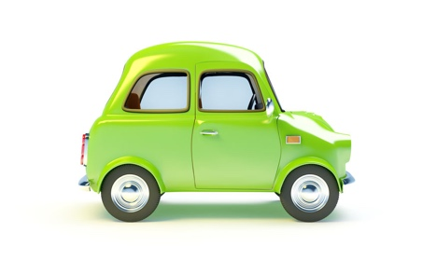

Overtaking

1 | You can overtake on the left on a one-way street
2 | If you are overtaking at night, you must beware of bends in the road ahead
3 | Lots of things can affect your stopping distance including:  - the condition of your tyres  - the road surfaces  - the condition of your brakes  - the driver
Box Junctions

4 | You may wait in a box junction when oncoming traffic prevents you from turning right
Fog Lights

5 | Fog Lights may be used when visibility is reduced to 100m or less
6 | Turn fog lights off when the fog has cleared
7 | If you leave them on, they can dazzle drivers behind and may be confused with brake lights
Weather conditions

8 | If you park on the road when it’s foggy, you should leave your parking lights on
9 | If the weather is very bad, consider if you journey is essential
10 | Check window and lights are clean and clear before setting of in bad weather
Lights

11 | If you’re driving at night and you’re dazzled by headlights coming towards you, be prepared to slow down or stop
12 | Have dipped headlights on if there are cars in front of you
13 | Have dipped headlights on in the daytime when visibility is poor
Coasting

14 | It’s dangerous to coast as you have less engine and braking control
15 | If you coast uphill, you will rapidly lose speed
16 | If you coast downhill, you will gain speed more quickly
Other

17 | Rumble Devices are designed to alert you of a hazard and make you aware of your speed
18 | Motorcyclists can slide on metal drain covers
19 | Chains will help prevent skidding in deep snow

