Vehicle Loading Facts List
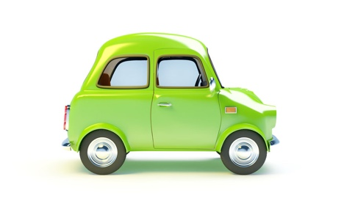

Heavy Loads

1 | Increase tyre pressure if carrying a heavy load. Check vehicle handbook for correct pressure
2 | Heavy loads will increase your stopping distance
3 | Heavy loads will reduce the vehicles stability
4 | The driver is responsible for making sure the load is correct
Towing

5 | Drivers cannot use the right lane of a three-lane motorway when towing
6 | Passengers are not allowed to travel in a caravan being towed
7 | If a trailer starts to swing from side to side, ease of gas and don’t do anything sharply
8 | A stabiliser will help keep a caravan being towed from
9 | A breakaway cable must be fitted to a towing trailer and towing vehicle.
Other

 | Children under 3-years should use a child seat when travelling in a car

